**ELEC-E7250 - Laboratory Course in Communications Engineering**

Preliminary exercises: WLAN measurements

Group members: Xingji Chen and Zheyuan Liu

1. What are the main differences between IEEE 802.11, 802.11a, 802.11b, 802.11n, 802.11ac? Hint: Concentrate on the physical layer differences, bandwidths, modulations, and other physical layer processing methods.

**IEEE 802.11 (Original Standard):**

Frequency Band: 2.4 GHz

Bandwidth: Up to 2 Mbps

Modulation Techniques: Frequency Hopping Spread Spectrum (FHSS) or Direct Sequence Spread Spectrum (DSSS)

Physical Layer Processing: Basic, with a focus on defining the MAC and PHY layers for wireless connectivity.

**IEEE 802.11a:**

Frequency Band: 5 GHz

Bandwidth: Up to 54 Mbps

Modulation Techniques: Orthogonal Frequency-Division Multiplexing (OFDM)

Physical Layer Processing: Introduced OFDM to reduce multi-path interference, significantly improving data rates and performance at the cost of shorter range due to the higher frequency band.

**IEEE 802.11b:**

Frequency Band: 2.4 GHz

Bandwidth: Up to 11 Mbps

Modulation Techniques: Complementary Code Keying (CCK) for higher data rates beyond the original DSSS method.

Physical Layer Processing: It was designed to be compatible with the original 802.11 standard while providing higher throughput and longer range but at lower speeds compared to 802.11a.

**IEEE 802.11n (Wi-Fi 4):**

Frequency Band: 2.4 GHz and 5 GHz

Bandwidth: Up to 600 Mbps with the use of four spatial streams.

Modulation Techniques: OFDM

Physical Layer Processing: Introduced Multiple Input Multiple Output (MIMO) technology, which uses multiple antennas to send and receive up to four spatial streams, significantly increasing throughput and reliability. Channel bonding (combining two or more channels to increase throughput) was also introduced.

**IEEE 802.11ac (Wi-Fi 5):**

Frequency Band: 5 GHz

Bandwidth: Up to several Gbps (Gigabits per second) in theory, with practical speeds often around 1.3 Gbps due to the use of wider channels (up to 160 MHz), more spatial streams (up to eight), and higher-order modulation (up to 256-QAM).

Modulation Techniques: OFDM

Physical Layer Processing: Enhanced MIMO technology (MU-MIMO) allows for the transmission of data to multiple clients simultaneously, significantly improving network efficiency and throughput. It also further increased channel bonding capabilities and introduced denser modulation schemes.

1. Find out the frequency range of IEEE 802.11 in 2.4 and 5.8 GHz in Europe.

How many WLAN channels are available in these frequencies?

How the 802.11n can create the channels in 5.8 GHz?

**2.4 GHz Band:**

Frequency Range: 2.4-2.4835 GHz in Europe.

Channels: Europe typically offers 13 channels in the 2.4 GHz band for WLAN usage, each with a bandwidth of 20 MHz. The channels are spaced 5 MHz apart, but since each channel is 20 MHz wide, adjacent channels overlap. It's recommended to use channels 1, 6, and 11 (or 1, 5, 9, and 13 in some cases) to avoid overlap in a typical WLAN setup.

**5 GHz Band:**

Frequency Range: The 5 GHz band encompasses a broader range, from approximately 5.150 GHz to 5.725 GHz, which includes the 5.8 GHz range as a part of it. The specific frequency range available for WLAN in the 5 GHz band can vary within this spectrum based on regulatory domain (Europe in this case).

Channels: The number of available channels in the 5 GHz band varies significantly due to the broader range of frequencies and the inclusion of various non-overlapping channels that can be 20 MHz, 40 MHz, 80 MHz, or even 160 MHz wide. In Europe, regulatory bodies such as the European Telecommunications Standards Institute (ETSI) govern the exact frequencies and channels available.

**How 802.11n Creates Channels in 5 GHz:**

Channel Bonding: IEEE 802.11n can utilize channel bonding to combine two adjacent 20 MHz channels into a single 40 MHz channel, effectively doubling the data rate in the 5 GHz band. This is achieved by using two adjacent 20 MHz channels as one wider channel. For example, it could combine channels 36 and 40 (each 20 MHz) to create a 40 MHz channel.

Dynamic Frequency Selection (DFS) and Transmit Power Control (TPC): In the 5 GHz band, 802.11n devices are also subject to DFS and TPC requirements to avoid interference with radar systems and to manage transmission power for optimal coexistence with other devices in the band.

1. Explain using the spectrum mask shown in Figure 1, how IEEE 802.11 radio channels should be used to have as many channels at (2.4 GHz bandwidth) as possible operating at the same time without causing interference to each other.

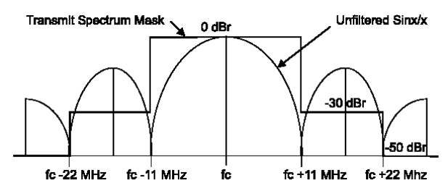

Figure 1 The transmit spectrum mask of a single channel in IEEE 802.11b [IE399a, pp. 219].

The spectrum mask shown in Figure 1 explains how IEEE 802.11 radio channels can be used to operate as many channels as possible simultaneously at 2.4 GHz bandwidth without causing interference with each other. The spectrum mask defines the limits on signal transmission strength around a channel's center frequency (fc).

From the diagram, it is apparent that the signal strength at the center frequency (fc) is 0 decibels relative to the carrier (0 dBr), and the signal strength decreases rapidly as the frequency deviates from the center frequency. At a deviation of 11 MHz from the center frequency, the signal strength drops to -30 decibels relative to the carrier (-30 dBr), and at a deviation of 22 MHz, it drops to -50 decibels relative to the carrier (-50 dBr).

To minimize interference and allow as many channels as possible to operate simultaneously, radio channels must be selected and configured in a way that the main energy distribution of each channel does not overlap. In the 2.4 GHz band, it is typically recommended to use channels 1, 6, and 11, as the spacing between these channels is sufficient to prevent such overlap. This arrangement ensures that the main lobes of each channel do not overlap at the -30 dBr level or lower, thereby reducing interference between adjacent channels.

Since the nominal bandwidth of each channel is about 20 MHz and there is at least 5 MHz spectral separation between adjacent channels, channels 1, 6, and 11 are separated by a sufficient spectral distance (at least 25 MHz) to meet the requirements of the transmission spectrum mask shown in the figure. Thus, despite the limited space in the 2.4 GHz band, it is possible to achieve three non-interfering channels. A similar separation should be maintained when selecting other channels to avoid interference.

1. What are the structures of the following frames: MAC data, ACK, RTS and CTS frames?

A MAC data frame carries the actual data payload between wireless devices and contains multiple fields such as frame control, addresses, sequence control, an optional quality of service control, and a frame check sequence for error detection.

An ACK frame is a small frame containing only the essential fields required to acknowledge the successful reception of a data frame, including frame control, the receiver address, and a frame check sequence for error checking.

An RTS frame is used to signal a request to send data on the wireless network, containing fields that include frame control, duration, the receiver and transmitter addresses, and a frame check sequence to prevent errors.

A CTS frame is sent in response to an RTS frame, giving the sender clearance to transmit data, and like the ACK frame, it contains minimal information: frame control, duration, receiver address, and a frame check sequence.

1. Explain the different parts of the DSSS physical layer in IEEE 802.11. Present the PPDU frame structure.

**Parts of the DSSS Physical Layer:**

Preamble: The preamble is used for synchronization. It allows the receiver to establish timing, gain control, and prepare for demodulation and decoding.

Start Frame Delimiter (SFD): This is a unique sequence that marks the end of the preamble and indicates the beginning of the PLCP (Physical Layer Convergence Protocol) header.

PLCP Header: This header contains the signal field, which provides information about the rate, length, and format of the packet. It also includes error detection codes.

PSDU (PLCP Service Data Unit): This is the actual data payload that is being transmitted. It's the part of the frame that contains the MAC layer frame.

**PPDU Frame Structure in DSSS:**

Sync: A synchronization field that allows the receiver to synchronize with the sender's signal.

SFD: Marks the end of the sync field and the start of the frame.

Signal: A field containing information about the transmission such as data rate and length.

Service: A field used for various service features in the transmission.

Length: Specifies the length of the frame.

CRC (Cyclic Redundancy Check): Used for error checking the PLCP header.

Data: This is the actual payload, which includes a MAC header, frame body, and frame check sequence (FCS).

1. Explain how the CSMA/CA channel sharing scheme works.

Listen Before Transmit: Devices first listen to the channel to determine if another device is transmitting. This is known as the carrier sense mechanism. If the channel is detected as busy, the device waits until it is free.

Random Backoff: Once the channel is idle, the device doesn't transmit immediately. Instead, it enters a random backoff time, which is chosen to reduce the chance of collision when multiple devices wait for the same channel. Each device picks a random backoff time, and they count down while the channel is idle.

Transmit After Backoff: When the backoff timer reaches zero, the device transmits its frame.

Acknowledgment: After a successful transmission, the receiving device sends an acknowledgment (ACK) frame back to the sender, confirming that the frame was received without errors. If the sender does not receive an ACK, it assumes the frame was lost or collided, and it will try to resend it after a new backoff period.

Collision Avoidance: To further reduce the possibility of collisions, the CSMA/CA protocol employs additional strategies:

RTS/CTS Mechanism: The Request to Send (RTS) and Clear to Send (CTS) mechanism is optional in CSMA/CA. A transmitting device first sends an RTS frame to the receiver, which, upon receiving it and ensuring the medium is clear, replies with a CTS frame. These frames alert all other devices to refrain from transmitting for the duration of the transmission, thus reserving the channel.

Virtual Carrier Sensing: Network Allocation Vector (NAV) is used for virtual carrier sensing. It indicates the amount of time the channel will be busy. When devices receive a frame, they read the NAV value and know how long to avoid transmitting.

1. Consider that STA A wants to transmit a single frame to STA B. Present the frame exchange between STAs A and B when RTS/CTS is used/not used. Calculate the maximum throughput (use UDP SDU length 1470) achieved for UDP traffic using the information presented in Table 1. Calculate the throughput using both long and short preambles. Remember to take into account the time needed for the frame exchange (Table 2). Hint: for throughput computation you packet transmission time, that is time for transmitting 1470 bytes together with all the headers and to this value you ass SIFS, ACK, DIFS and back off times. The resulting value is total time for transmitting 1470 bytes.

Table 1 Header information for an UDP packet in IEEE 802.11b.

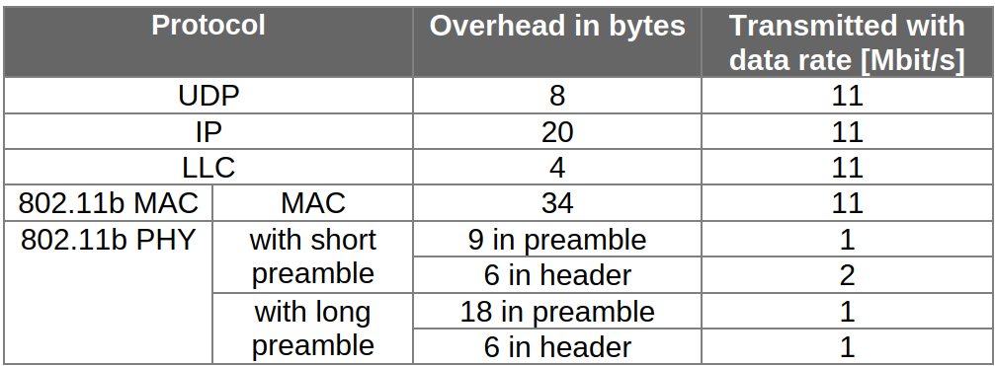

Table 2 The most common interframe spaces in IEEE 802.11.

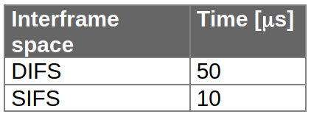

For short preambles:



The ACK is usually the same size as the MAC header, so 34 bytes. The time required to transmit an ACK is



DIFS and SIFS times are 50 microseconds and 10 microseconds respectively





So, the frame exchange time is



The throughput is



For long preambles:



So, the frame exchange time is



The throughput is



1. Assume a voice is compressed to 64 kbit/s and a voice packet is created from the samples collected over 20 ms. How many bits are in one voice packet? How many packets a voice packet buffer may have if it has to comply with good, medium, or bad voice quality?

Number of bits in one packet = Bit rate × Duration in seconds

So the number of bits in one voice packet is 1,280 bits.

For a packet duration of 20 ms and a jitter tolerance of 200 ms, the number of buffer can hold is 10.